Laboratory Exercise 3

Ocampo, Paolo

1. Write a program that displays “Hello” in one line, and “World” in another line using exactly two (2) COUT statements.

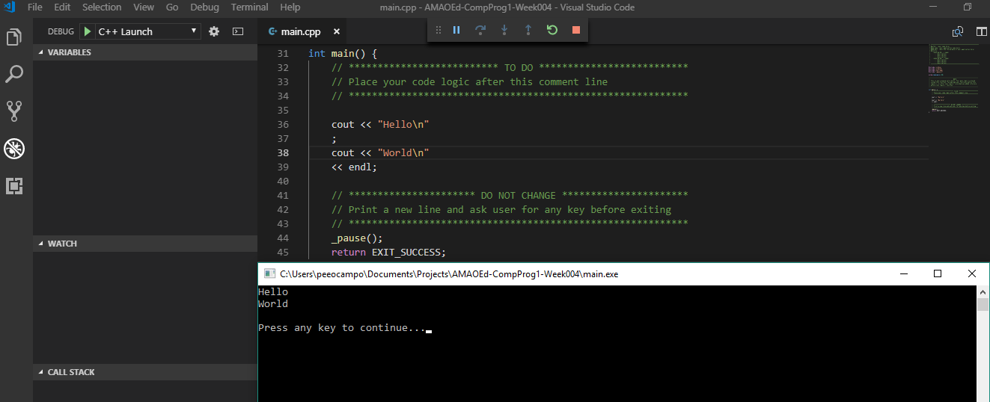

1. Write a program that displays “Hello” in one line and “World” in another line using exactly ten (10) COUT statements.

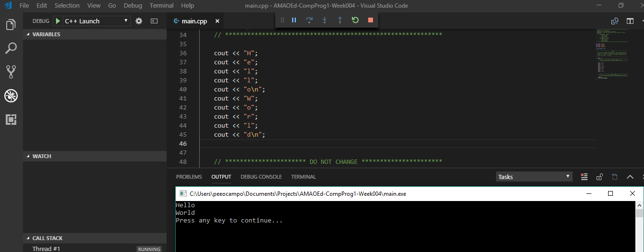

1. Write a program that displays “Hello” in one line and “World” in another line using exactly one (1) for the “Hello” and exactly five (5) COUT statements for the “World”.

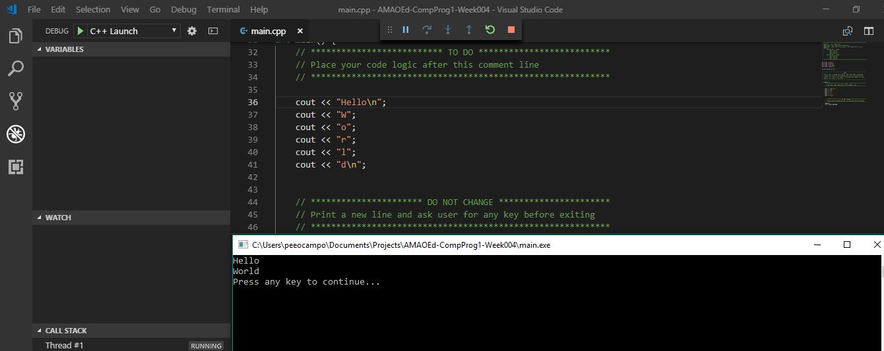

1. What can you conclude from this activity?

The activity is interesting and fun as it now showcases the endless possibilities of programming. Using the different problem scenarios, it enables the programmer to experiment and try different ways in analyzing and simulating using the codes. I must say that coding should be taken carefully as any syntax error or incomplete information would result in a debugging error and would prevent the program from running.

Overall, I must say that it becomes more interesting and would love to try out more exercises in the coming modules and machine problems.